IRP Funds ($250,000 loan maximum)

Community Works North Dakota www.lcdgroup.org
All of North Dakota in communities 50,000 and under. 701-667-7600

Dakota Business Lending https://www.dakotabusinesslending.com
All of North Dakota in communities 50,000 and under. 701-293-8892
1-800-611-8997

Dakota Medical Foundation http://www.dakmed.org/ (RLF Info N/A)
Health related businesses and non-profits in North Dakota 701-271-0263
in communities of 50,000 or under.

Impact Foundation http://www.dakotacdc.com/ (RLF Info N/A) Throughout North Dakota except Cass and Burleigh Counties 701-293.8892
and communities of over 25,000 population. 1-800-611-8997

Lake Agassiz Development Group http://www.lakeagassiz.com/
Region V: Cass, Ransom, Richland, Sargent, Steele and Traill 701-235-1197
Region IV: Grand Forks, Nelson, Pembina and Walsh
Region III: Benson, Cavalier, Eddy, Ramsey, Rolette and Towner

Lewis and Clark Regional Development Council http://lcdgroup.org/
Region VII: Burleigh, Emmons, Grant, Kidder, McLean 701-667-7600
Mercer, Morton, Oliver, Sheridan and Sioux

Roosevelt Custer Regional Council https://www.roosevelt-custer.org/
Region VIII: Adams, Billings, Bowman, Dunn, Golden Valley rcrc@ndsupernet.com
Hettinger, Slope and Stark 701-483-1241

Souris Basin Planning Council http://www.sourisbasin.org/
Region II: Bottineau, Burke, McHenry, Mountrail, Pierce 701-839-6641
Renville and Ward

South Central Dakota Regional Planning Council http://www.scdrc.org
Region VI: Barnes, Dickey, Foster, Griggs, LaMoure, Logan 701-952-8050
McIntosh, Stutsman and Wells

RBEG/RBDG
Revolving Loan Funds

Anamoose RLF http://anamoose.com/home.php (RLF Info N/A)

Cavalier County JDA http://www.ccjda.org/

Dakota Business Lending https://www.dakotabusinesslending.com/
Benson, Billings, Dunn, Hettinger, McHenry, Pierce
Rolette, Sioux and Slope Counties

Divide County JDA http://www.dividecountynd.org/ (RLF Info N/A)

Oyate Development Corporation 701-854-8122
Limited to Native American Businesses

Towner County EDC http://www.candond.com/towner_county/tcedc.htm (RLF Info N/A)

Tri-County RDC N/A
Region I: Divide, McKenzie and Williams

Underwood RLF N/A

REDG
Revolving Loan Funds (See map for coverage areas)

Burke-Divide Electric http://www.bdec.coop/
1-800-472-2983
Cavalier REC 701-256-5511

Dakota Valley Electric http://dakotavalley.com/
1-800-342-4671

McLean Electric http://mcleanelectric.com/

Mountrail Williams Electric http://mwec.com/ (RLF Info N/A)

North Central Electric http://www.nceci.com/

Northern Plains Electric http://www.nplains.com/

Northwest Communications http://www.nccray.com/ (RLF Info N/A)

Polar Communications https://www.polarcomm.com/
701-284-7221
Reservation Telephone http://rtc.coop/ (RLF Info N/A)

Roughrider Electric http://roughriderelectric.com/

Slope Electric http://www.slopeelectric.coop/ (RLF Info N/A)
701-579-4191
SRT Communications www.srt.com
701-858-1200

(RLF Info N/A)
United Telephone http://www.utma.com/ (RLF Info N/A)
701-256-3475
Verendrye Electric http://www.verendrye.com/
1-800-472-2141

RMAP Funds ($50,000 loan maximum)
Lake Agassiz Development Group http://www.lakeagassiz.com/
Throughout North Dakota less cities over 50,000 population. 701-235-1197

Oyate CDC 701-854-8122
Standing Rock Sioux Reservation

*All loan funds are limited to communities of 50,000 or less. IRP regulation previously limited IRP funds to communities of 25,000 or less. Recent changes have allowed IRP’s to use funds in communities of 50,000 or less if the work plan allows. Please check with the individual IRP in your area for their population limitations.

**Not Available (N/A)

Regional Planning Councils
http://www.business.nd.gov/resources/RegionalCouncil/

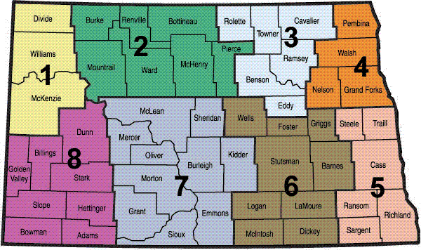

Rural Electric Cooperatives
http://www.ndarec.com/content/ndarec-members

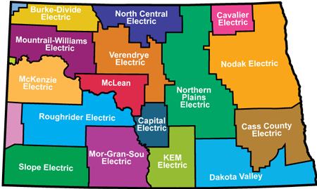

Rural Telephone Cooperatives

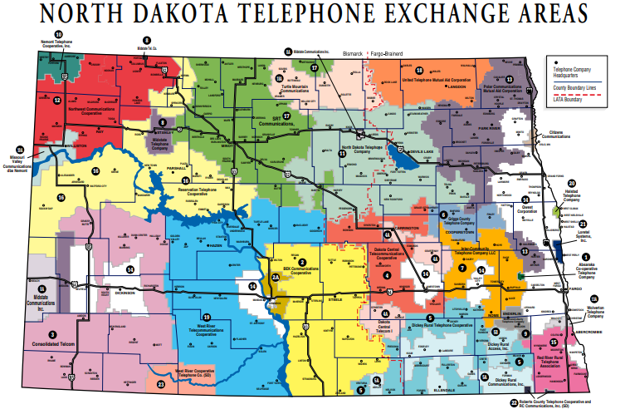

Native American Reservations
http://www.nd.gov/indianaffairs/?id=18

